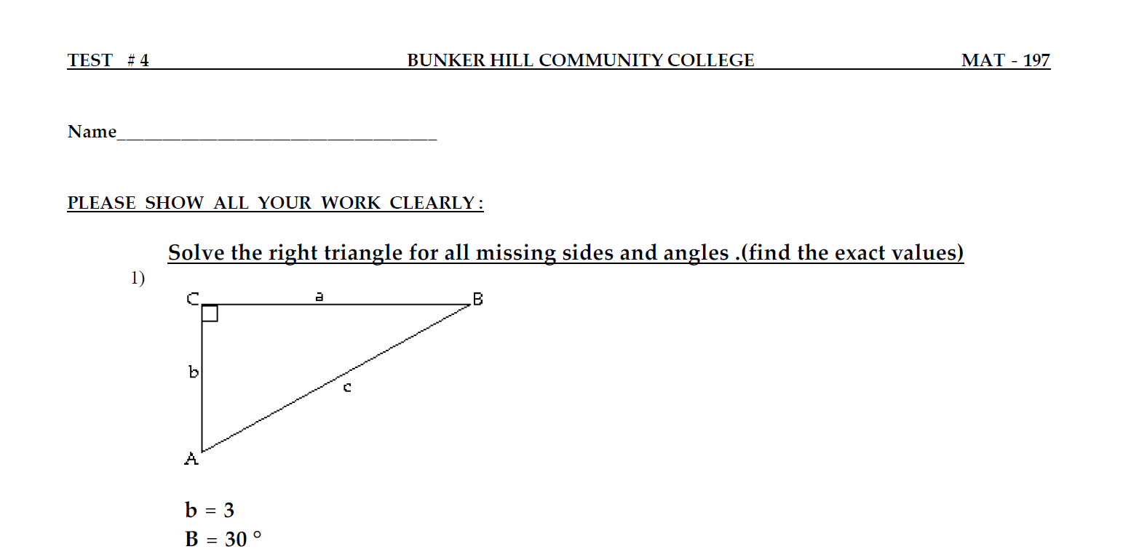

$$In ΔABC,$$
$$\sin{{30}^{0}}=\frac{b}{c}→c=\frac{b}{\sin{{30}^{0}}}=\frac{3}{\sin{{30}^{0}}}=\frac{3}{\frac{1}{2}}=6$$
$$c=6$$
$$a=\sqrt{c^{2}-b^{2}}=\sqrt{36-9}=\sqrt{27}=3\sqrt{3}$$
$$A+B+C={180}^{0}→ C=180-30-90={60}^{0}$$

$$a=3 \sqrt{3} , b=3, c=6$$
$$A={60}^{0}, B={30}^{0}, C={90}^{0}$$

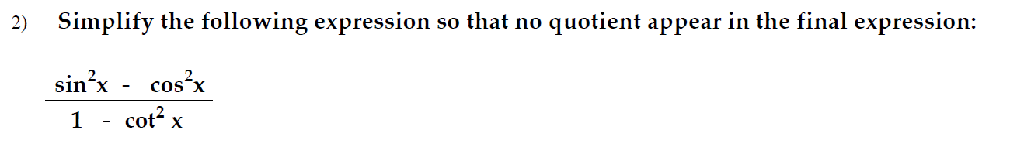
$$\frac{\sin^{2}{x}-\cos^{2}{x}}{1-\cot^{2}{x}}→ \frac{\sin^{2}{x}-\cos^{2}{x}}{1-\frac{\cos^{2}{x}}{\sin^{2}{x}}}→ \frac{\sin^{2}{x}-\cos^{2}{x}}{\frac{\sin^{2}{x}-\cos^{2}{x}}{\sin^{2}{x}}}→\sin^{2}{x}$$
$$\frac{\sin^{2}{x}-\cos^{2}{x}}{1-\cot^{2}{x}}→\sin^{2}{x}$$

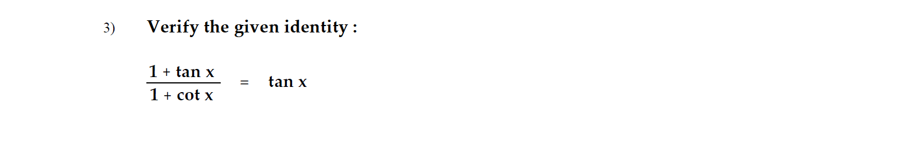
$$\frac{1+\tan{x}}{1+\cot{x}}→ \frac{1+\tan{x}}{1+\frac{1}{\tan{x}}}→ \frac{1+\tan{x}}{\frac{1+\tan{x}}{\tan{x}}}→\tan{x }$$
$$L.H.S. =R.H.S.$$

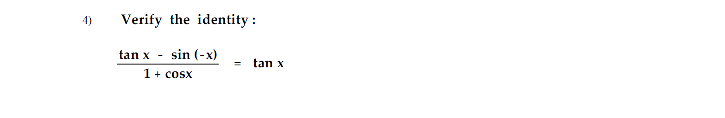
$$\frac{\tan{x}-\sin\left(-x\right)}{1+\cos{x}}→\frac{\frac{\sin{x}}{\cos{x}}+\sin{x}}{1+\cos{x}}→\frac{\frac{\sin{x}+\cos{x}\sin{x}}{\cos{x}}}{1+\cos{x}}→ \frac{\frac{\sin{x}\left(1+\cos{x}\right)}{\cos{x}}}{1+\cos{x}}→\frac{\sin{x}}{\cos{x}}→\tan{x}$$
$$L.H.S. =R.H.S.$$
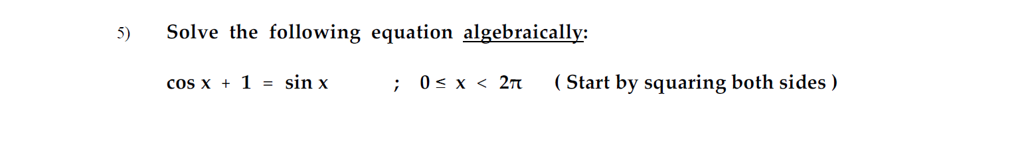
$$\cos{x}+1=\sin{x}$$
Squaring both sides
$${\left(\cos{x}+1\right)}^{2}=\sin^{2}{x}$$
$$→\cos^{2}{x}+2\cos{x}+1=\sin^{2}{x}$$
$$→\cos^{2}{x}+2\cos{x}+\cos^{2}{x}+\sin^{2}{x}=\sin^{2}{x}$$
$$→2\cos^{2}{x}+2\cos{x}=0$$
$$→2\cos{x}\left(\cos{x}+1\right)=0$$
$$→ \cos{x}=0, \cos{x}+1=0$$
$$→x =\frac{π}{2}, \cos{x}= -1$$
$$→x=\frac{π}{2} , x=π$$
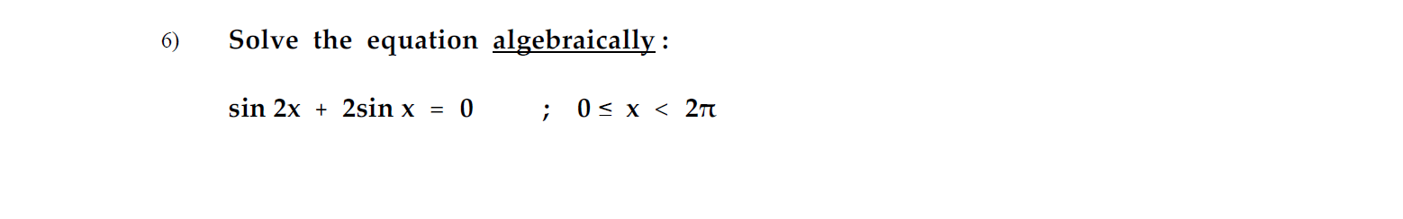
$$\sin{2x }+2\sin{x}=0$$
$$→2\sin{x }\cos{x}+2\sin{x}=0$$
$$→2\sin{x}\left(\cos{x}+1\right)=0$$
$$→\sin{x}=0 , \cos{x}+1=0$$
$$→x=0, \cos{x}= -1$$
$$→x=0 , x=π$$

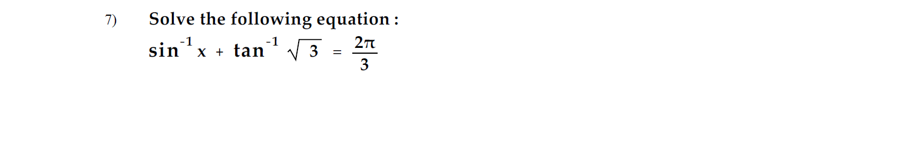
$$\sin^{-1}{x}+\tan^{-1}{\sqrt{3}}=\frac{2π}{3}$$
$$→\sin^{-1}{x}+\frac{π}{3}=\frac{2π}{3}$$
$$→\sin^{-1}{x}=\frac{π}{3}$$
$$→x=\sin{\frac{π}{3}}$$
$$→x=\frac{\sqrt{3}}{2}$$

$$\cos\left(\sin^{-1}{\frac{3}{5}}+\cos^{-1}{\frac{5}{3}}\right)$$

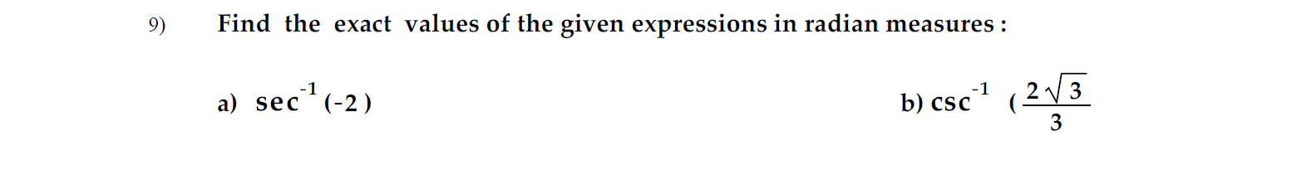
a)
$$\sec^{-1}{(-2)}$$
$$→π-\sec^{-1}{2}$$
$$→π-\frac{π}{3}$$
$$→\frac{2π}{3}$$

b)
$$\csc^{-1}{\frac{2\sqrt{3}}{3}}$$
$$→\csc^{-1}{\frac{2}{\sqrt{3}}}$$
$$→\frac{π}{3}$$

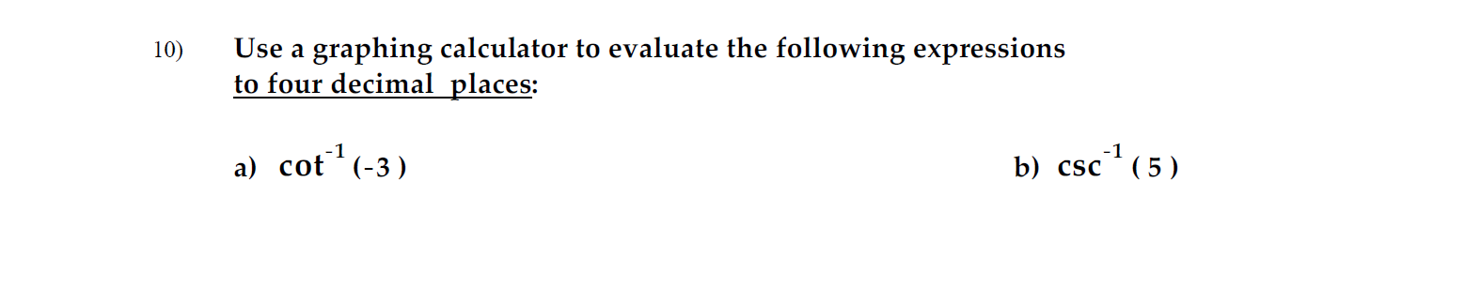a)
$$\cot^{-1}\left(-3\right)$$
Using calculator
$$→ 2.819842 \sim 2.8198$$
b)
$$\csc^{-1}\left(5\right)$$
Using calculator
$$→ 0.2013579→0.2014$$

